An Analysis of Netflix's Future Success

Group 3 Authors: Shreyaskumar Kathiriya, Natasha Waters, Yuzhu Pu, and Xinyu Chen

MG-GY 6083 Economics

Professor Pavlos Mourdoukoutas

Spring 2019

Table of Contents

Abstract Page 2

Introduction Page 3

Industry Analysis Page 3

Porter’s Five Forces Page 3

PEST Analysis Page 5

Firm Analysis Page 8

SWOT Analysis of Netflix Page 9

Netflix’s Struggles and Strategy Analysis Page 10

Analysis of Netflix’s Future Sustainability Page 11

Netflix Devices and Partners Page 11

Netflix’s Original Content Page 12

Netflix’s Subscription Plans and Binge-Watching Page 12

Netflix’s Brand Positioning Page 13

Conclusion Page 13

Exhibits, Charts, and Graphs Page 14

Bibliography Page 17

**Abstract**

This paper will take you through a brief introduction of the rising subscription industry and changing trends within it, with a major focus on Netflix’s position in it. The first section of the study, an industry analysis distinctly split in two methods: Porter's Five Forces, which is used to understand and identify who holds the balance and power in the market, and a standard PEST Analysis, used to look at the industry as a whole considering factors that directly or indirectly affect it. Further, a firm analysis is conducted through a detailed implementation of SWOT analysis of Netflix at business level is done to illustrate what they must consider when competing against other players in the subscription industry. Finally, Netflix’s key strengths are articulated and discussed, with a concluding statement on the paper as a whole.

**Introduction**

Despite the increasing competition in the streaming industry, Netflix manage to remain the leading position in market. Netflix’s success once disrupted the whole industry, forcing the old media form to change the business model. Netflix undoubtedly has advantages over his competitors. Netflix focuses on streaming on-demand content and researching customer’s data to provide better service. However, those advantages become weaker as more players entering and similar business model prevailing the industry. Netflix started to invest heavily in creating original programs, paving the path for the upcoming streaming war.

**Industry Analysis**

**Porter’s Five Forces**

When investigating the digital broadcasting industry in relation to Porter’s Five Forces of Framework model, various different key points were taken into consideration. As can already be assumed, digital media is strongly dominating the way society intakes various communication channels, such as television shows, music, and movies. The five forces that were used to analyze this industry bring light to the fact that though the threat of substitutes is high, the bargaining supplier and buyer power is much higher. The digital media industry has demonstrated how it has the ability to disrupt traditionally dominated industries, and continue to build a large enough market that is consistently innovated in a way that prevents other industries from taking over.

**Threat of New Entrants**: Threat of new entry is moderate amongst the digital streaming media industry. Companies(i.e. Netflix and Hulu) and TV channels(i.e. HBO and Disney) have steadily made the move to integrate onto the streaming platform, introducing subscription plans that consumers can choose from in order to enjoy various films and tv shows. However, despite many companies attempting to join onto the streaming bandwagon, there exists the struggle of being able to provide original content, a variety of selections, and plan options to consumers. It is due to this obstacle, that the threat of new entrants is not high due to the various companies that have already made a large impact in the streaming industry, which have set a platform that does not allow for many to join. In addition, there is a lack of competition advantage that can exist for new entrants to take due to most popular streaming services taking on the big movie and television franchises that exist.

**Power of Suppliers:** When it comes to digital streaming services, the power of suppliers refers to the television studios/networks that produce movies and television shows. It is with such services that suppliers have a bargaining power when it comes to choosing which streaming service they wish to allow to purchase the rights that can be used to put the films or movies on their platform. The power of suppliers has shifted as the streaming industry has grown; therefore, as a result, the power of suppliers was initially high at the start of the streaming service industry, but now presently stands as only moderate(Investopedia 2019). When the streaming industry initially started, the power of suppliers stood high due to the fact that it was the movies and television shows that suppliers had that streaming companies needed in order to not only give as a product to subscribed consumers, but to also stand ahead of others in competition. As streaming companies began to take on more popularity, however, a drop went in the power of supplier from high to moderate. Though streaming companies still need to bargain with suppliers on their services, the power of suppliers is no longer as high due to the fact that the popularity of the company gives the company power. For example, if a popular streaming company wishes to stream a selected movie, the company which owns the movie may feel more inclined to give a price that the streaming company is in desire of in order to gain more views on the movie(Investopedia 2019). The higher the popularity of the company, the more users it has, thus resulting in the more potential views for the movie or television show. As a result, the power of suppliers stands at a moderate level due to the popularity of streaming services today.

**Power of Buyers:** The power of buyers in the streaming industry stands quite high amongst other forces. While suppliers had the power of bargaining deals to allow for streaming services to have product options, buyers have the power the of influencing the way in which a streaming company chooses its streaming content, as well as the plans it wishes to make available. As a result of this, streaming companies are forced to create subscription plans at reasonably low prices in order to maintain a strong status with competitors, and a good choice for consumers. Therefore, the power of buyers within this industry stands high due to the fact that they largely control both the streaming content and plans offered by the streaming company.

**Threat of Substitution:** Threat of substitution stands as the highest power within Porter's Five Forces for the streaming industry. As witnessed in the ongoing competition between Netflix and Hulu, who currently stand as the two biggest streaming subscription companies within the United States, the ability for one company to substitute the other is always changing, and steadily increasing. This threat continues to remain high due to the fact that such streaming sites are consistently obtaining more content that appeals to consumers, and thus consumers may want to shift to the different sites based on their preferences.

**Competitive Industrial Rivalry:** When examining the competitive rivalry force inside the streaming subscription industry, one is able to see that this stands at a high level. As previously mentioned within the other forces, there exists various different streaming subscription companies, ranging from Netflix to HBO Go. As society continues to move towards a digitization stage, in which traditional media outlets are forced to adapt, the popularity of gaining a subscription to such services rises. As a result, the competition remains high due to the fact that companies are constantly reaching out and trying to obtain the consumers who are making the move onto the subscription services.

**PEST Analysis**

Digitization of services like movies, television shows and music has several impediments before it reaches the audience. Most of these get underlined in the PEST analysis. PEST analysis considers the wide array of factors that play a role in deciding the degree of content and price of the digital service, which is accurately bifurcated under Political, Economic, Socio-cultural and Technology related factors.

**Political Factors:** Services like television shows and music undergo crucial filtering by countries before they are aired or made available to the audience. Netflix is a world leading internet entertainment service, and isn’t available in all the countries. Similarly it cannot offer content from all countries either. U.S government has restricted companies from doing business with countries like North Korea, Syria and Crimea. It is not only limited to that. Spotify, being one of the dominating digital music service providers, are receiving serious criticism from the subscribers who cannot access certain music labels or artist due to the political factors that restrict Spotify from making it available. U.S restriction is not the only restriction Netflix faces, censorship and permissions are another set of political factors that affect these companies. China is one of the biggest economies with enormous growth for any company that steps there, but the world’s best streaming services are all geo-blocked in China. You cannot watch Netflix, Amazon Instant Video, or HBO GO because these services need permission from the Chinese government first. China has strict content censorship, and for any of these services to enter their market they will need to abide by China’s censorship rules. This is not only the case with China; there are many countries which have content restriction. Netflix has content restriction in 130 countries, and there is absolutely nothing they can do about it. Different taxation scheme in different political region limits the reach of these services too. Country with a higher tax on the service operation could have high monthly fee for the subscription.

**Economic Factors:** Economical factors can affect the service in both a positive or a negative way. Increasing liberalization of trade policy can help companies like Spotify, Netflix and other similar businesses to flourish in global portions. A drop or halt in consumer spending can cause huge sums of subscriber loss to these companies, which can make it lethal for them to exist in the market. It is also witnessed that economic swings can drastically change consumer spending behavior, and companies cannot foresee any of this. Moreover, on the industry level, the rise in streaming and music services with similar product makes the competition cutthroat. Also, piracy has been a matter of concern for these companies offering streaming services. Though piracy has been made illegal, it has not stopped millions of people from getting the content for free by a dozen other mediums. These companies which work on a monthly fee model lose big from these other free resources. The least addressed or known of factor that affects these services are the currency rates. These streaming services rely heavily on the global revenue they get from the services they provide in other countries, and fluctuating currency rates make a big difference on what they receive on the other hand-cite.(Binder, 2018) Not only this, but a weak dollar can force a company to raise the monthly fee, making it less desirable over the local service providers by the consumers.

**Social Factors:** Companies and services that earn their revenue from the online content has plethora of social factors that they have to consider before making any content available to any particular region. Companies similar to Netflix and Amazon Prime generally have to meet certain ethical standards which vary from society to society and person to person. Any direct or indirect hit on these sensitive beliefs or practices can turn out to be a boycott in unison on these services. It has also been realized that rising inequality has affected the consumer behavior towards these services. Ethical lines are not the only hindrance in the working business of these companies, but also morality is. Morality is subjective, and content that is immoral to one group of people can be absolutely normal to the other group, and companies normally dangle between personalizing content on the basis of the region and beliefs of the people. One of the most important social factors would be religious conflicts. Content that blemishes one’s religious practice or way of living is detested, and companies can be forced to take them off their services and can be dragged to court for the damages they made. Aside from these intense factors, there are many other social factors that revolve around the credibility of a company’s service like their work environment and how they treat their employees. Netflix is ranked first in keeping their employees satisfied, with more than 71% of employees stating that they are being compensated fairly at Netflix-cite.(Bort, 2017) These factors not only show the hospitality of the company to the outside world but also keep the employees loyally intact with company.

**Technology Related Factors:** When a consumer decides to subscribe to services like Netflix or Spotify they expect consistent quality content. This does not only mean making better quality available to consumer but also to come up with solutions to keep the size of the data feasible and storable. Companies use compress techniques to reduce the size of the data for the storing purpose. Companies cannot heavily rely on the current compress techniques, and need the research and development department to better their compressing techniques with the constantly improving quality of the content. Moreover, companies with monthly subscription attract their clients not only with the content but the experience and aesthetic the website provides, hence companies invest heavily on UI and UX designs. Netflix’s change in UI and algorithm confused their customers, and hence was filled with criticism over that-cite (Joon Ian, 2017). Companies also have to better their recommendation system with the growing complicated taste of the consumer and competitors working towards the same goal. The most anticipated and talked about technology factor is associated with patents and copyrights. Companies have to keep renewing their patents selectively to keep their uniqueness. Moreover, maturing technology is one more factor, as the technology is used extensively by many competitors it saturates and demands for an innovation. Companies constantly keep developing technology that would reduce cost of development in order to drop the monthly subscription fees.

**Firm Analysis**

**Netflix’s SWOT**

**Strengths:** Netflix features a variety of strengths which enables it to have a higher placement above its competitors. One of the first key one is its large customer sources. It not only is in the United States, but it has a worldwide customer base. This then leads into it having a strong brand recognition. Everyone knows “Netflix”, it’s easy to remember and the logo is striking.

Further, it has a use of big data. Users only need to log in to Netflix, and each time they click, play, pause, or even watch the video for a few minutes, this will be used as data to enter the background analysis. German data scientist Sebastian Wernicke pointed out that the Netflix process has two steps: separating the data for analysis; reassembling the data for full use-cite. Netflix also possesses an excellent customer-relationship-management(CRM) system. Netflix has a heavy emphasis on human connections and service. It focuses on delivering the best value due to same cost. This is evidenced in its strength for the ability to provide many alternative streaming methods through cell phones, computers, televisions, and tablets.

**Weaknesses:** Though Netflix features many strengths, it also has a few weaknesses. The first notable one is its high cost of original programming. Although the original content can bring Netflix enormous profit, no one knows how long can the sustained high investment will last. Further, Netflix has a weakened openness. Since Netflix seems want to become monopoly in the streaming industry, it has a mass acquisition of artists and publisher. Since more than 50% of the creators are gathered by the same company, the freedom of creation will gradually disappear-cite(Beauvoit, 2018).Netflix also has a international market regulation due to the fact that it is within different countries with different regulations, which will cause more time and money to be spent. Moving aside from this, there exists many competitors within the industry, such as: Amazon, AMC Cinema, and FOX (Fox Broadcasting). All of which are launching network viewing platforms and various App terminals. Lastly, there is an unknown legal dispute that startedin 2015. Netflix spent $12 million to purchase the movie "The Beasts", which was opened to users on the Internet in advance. When the film was attempted to be released in the theater, the four major theaters in North America, Emperor AMC, Carmike and Cinemark are all refused to cooperate (Mcnary, 2015).

**Opportunities:** Due to Netflix’s large stance, it has a range of opportunities available to it. Its most notable is its bet on its original content.In 2013, Netflix was beginning to originality. Its investment in original content reached $6 billion last year (Koblin, 2017). The content also covers dramas, movies, documentaries, talk shows, reality shows, and children's programs. Netflix’s original content increased by 3050% in the four years from 2012 to 2016(Hayden, 2017). Another opportunity that exists is Netflix’s great opportunity in an oversea market. For example, China and India are both countries that have incredibly large populations, Netflix is working to find a way to enter their market in order to gain a large amount of consumers. The last main opportunity can be seen in the minority language teleplay**.** This niche strategy is based on “exotic style,” which means that it attracts audiences who are curious about exotic countries. Netflix can use this to their advantage in obtaining more users.

**Threats:** There are only a few threats that currently stand to Netflix. The first of which is its increased competition. Hulu, HBO, and YouTube are all competing for viewers to subscribe to their platform. Thus, it is estimated that more new creative companies want to join this game. Secondly, there exists the threat of illegal video streaming. With the development of the internet, there are more ways to get videos through some illegal free website. Since these resources will be free, it will be way more attractive than the paid TV program. Lastly, there are different national policies. In order to expand into Asia countries for example China and India, all the policies need to be required. Just like in China, all the video streaming need to go through by the government and then display on the screen, there will be large possibility that some hot content will be disapproved and censored.

**Netflix’s Struggles and Strategy Analysis**

**Struggles:** As over-the-top video revenue experience stable growth in past decade and is projected to grow more in the future, streaming companies are facing fierce challenges. Netflix is the market leader in the streaming industry in the U.S., with 55 million domestic subscribers by the end of first quarter of 2019(Molla, 2018). However, Netflix is constantly challenged by the growing competition and changing market trends(see Appendix A).

While Netflix had a steady growth of subscribers globally for last decade, there is an obvious trend of relatively weak growth domestically. Although the demand for accessing online content is increasing daily, the playing field of the streaming industry becomes more competitive with new players squashing in. Netflix is spending more on original programming due to increasing dynamics in the streaming industry. Walt Disney Co. decided to end its profitable relationship with Netflix and to start its own streaming division, resulting in growing competition with the old partner Netflix, and the meantime Walt Disney withdrew its original contents from Netflix-cite(Solasman, 2019).Along with the factor that social media sites trend to invest more heavily in video services, challenges for streaming companies in the industry are unprecedented. Only reaching more customer basis may not be good enough to survive in the industry. To achieve sustainable growth, companies like Netflix need to have a stable supply of original content with good quality in order to compete with the classic streaming series that have copyright and growing new entrants.

**Strategy:** Netflix, as the market leader, has the most capacity to adapt to technological disruption as well as threats by the new entrants. Netflix owns a huge customer base both internationally and domestically, which provides huge advantages over others in the original content space. In fact, Netflix is splurging heavily on original content, spending 15 billion(see Appendix B)in 2019, and a projected 17.8 billion spending in 2020(David, 2018).

Such long-term strategies may perfectly suit Netflix, not only because of the huge quantity of its customer base, but also because of the data achieved from customers. In other words, Netflix has a direct relationship with its customers, so they know what contents are preferable. This becomes handy when dispersing amongst “acquaintance”. However, using capital heavily in original content slate may stall the growth of new subscribers. The balance is between acquire new customers or create more sustainable contents for future growth.

**Analysis of Netflix’s Future Sustainability**

**Netflix’s Devices and Partners**

Netflix launched its own small device called “Netflix Player”, which could connect to televisions and enable subscribers to watch the shows from the web. While it obviously boost company’s online subscriber base, it may undermine partnership with Netflix’s existing hardware makers. Eventually, “Netflix Player” segment is operated within a separate company that spun out by Netflix. This risky decision turns out to be a publicity boon for Netflix. Not only did Netflix attract more online subscribers, but also did the company form the partnership with other huge online streaming platforms, such as Xbox, LG and Samsung. With the development of the Netflix software, those streaming partners with Netflix are now all equipped with Netflix software, so that Netflix’s service is available on any streaming platforms like blu-ray players, set-top boxes, laptops and mobile devices. Netflix’s strategy on its launched devices and exploit the potential customers on various streaming platform, and with relationship built with other streaming partners, Netflix manage to retain their online customers within other platforms.

**Netflix’s Original Content**

Before Netflix producing their original content, they need to buy resources from other companies. Since the Netflix only buy those contents meeting the results shown by Cinematch data, more and more studios demand Netflix to buy the show in bulk. So, after the Netflix develop their own content. The cost of buying those unnecessary content will be reduced significantly. And the Netflix’s original content launch all the episodes of a season at once, after watching the whole season, the relationship between the audiences and the content will be solid. Also, unlike Disney, the Netflix has a wide variety of all the aspects. More differences means more customers, as long as they can combine their data and create new shows, there will only be successes.

**Netflix Subscription Plans and Binge-Watching**

Netflix currently offers three different subscription plans: basic, standard, and premium. The strength in Netflix does not come from its variety of plans, but rather, the benefits that are included in all, including the basic option, as evidenced in Exhibit A. All plans provide the same amount of streaming content, at an unlimited rate at which one can re-watch them. The plans differ in the fact that some offer high definition and ultra high definition, as well as the amount of screens that consumers can use on the same Netflix account simultaneously. With the differences between the plans being slim, Netflix is given a great strength against others companies due to the fact that one can purchase the cheapest plan and obtain the same amount of content as any other, with zero commercials. Netflix's largest competitor, Hulu, offers four different plans; however, such plans are flawed since the content in which a consumer can stream on them varies, as seen in Exhibit B. Hulu's most basic plan starts at $5.99 a month, and offers a wide range of streamable content with commercials, and this same plan can have an upgrade of $11.99 a month in order to have no advertisements. However, consumers can pay $44.99 a month to have a larger amount of streaming content as they can have access to both streaming content, as well as live television with advertisements. The same plan can be upgraded to $50.99 to have zero advertisements. Due to Hulu’s failure to provide zero advertisements for even its most basic plan, Netflix finds itself with a high strength as its consumers now have the ability to enjoy binge-watching its content without interruptions. This ultimately gives Netflix a larger amount of time spent on its site from consumers, as well as more views on its content, thus putting it ahead of its competitors.

**Netflix’s Brand Positioning**

Netflix is not only the leader in subscription based services but was also among the first few to step in this market. This not only gives it an advantage of having minimal to no competition in the initial growing phase but has also given it plenty of time to build customer taste and acquire the customers that are loyal, and not easy to convert to other new players in the market. Netflix has a remarkable service with content that target a particular audience in the customer base, 89% are likely to be 18-24 along with a large skew aged between 25-39, and this sets it apart from other services**.**

**Conclusion**

From its first step into the streaming industry, Netflix has continued to prove that it is a fierce competitor amongst other companies. It has the ability to not only stream on various platforms, but to also provide its consumers original content that they would not be able to gather anywhere else. Furthermore, Netflix's ability to provide zero commercials on all plans, including its cheapest option, allows for its users to binge any movie or television show without any interruption. This key strength allows for Netflix to gain a high amount of views at a quick rate when up against competitors. Netflix continues to set a standard across the board for all streaming services, and thus is leading the competitive advantage factor, serving as one of the biggest titans of its industry.

**Exhibits, Charts, Appendixes**

**Appendix A:**

Netflix streaming subscribers

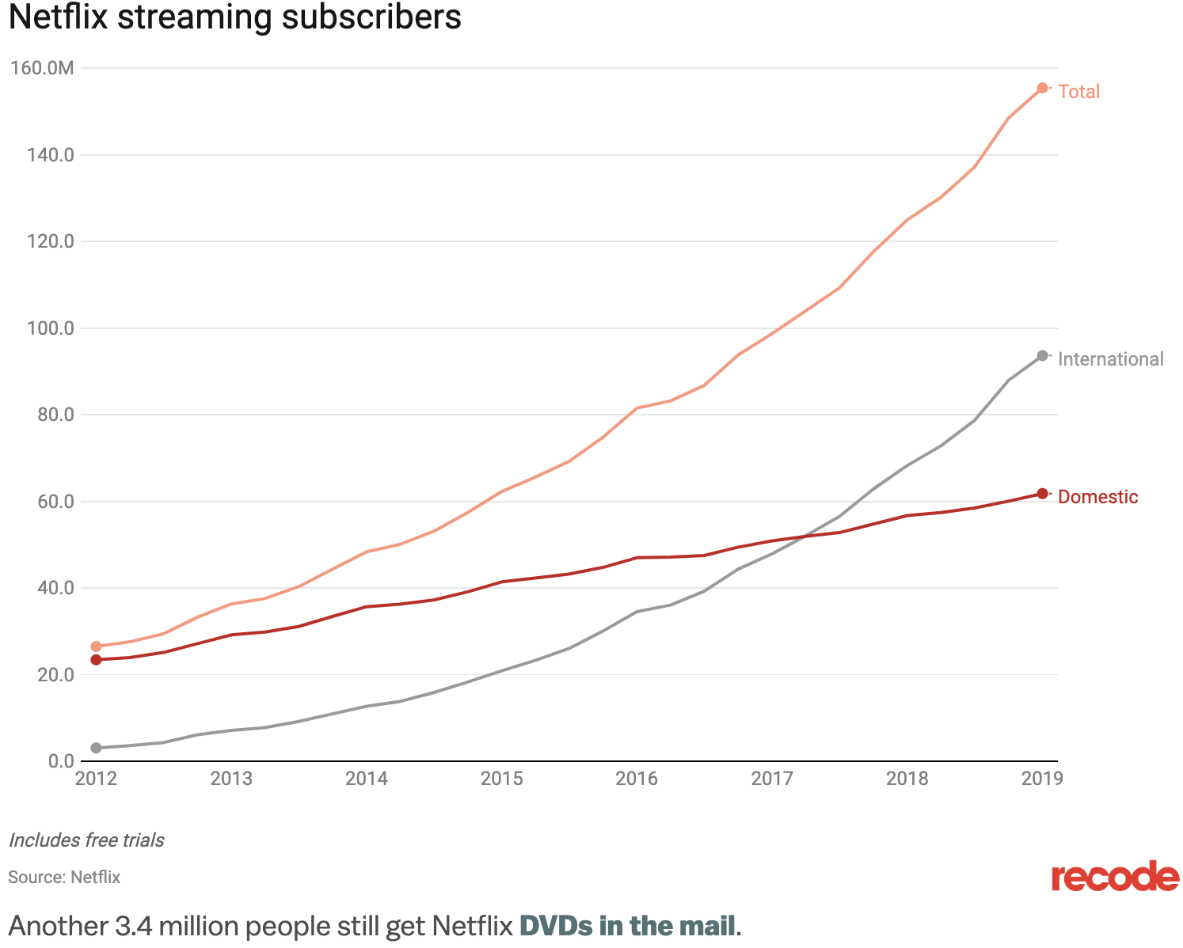

(Molla, 2018)

**Exhibit A:**

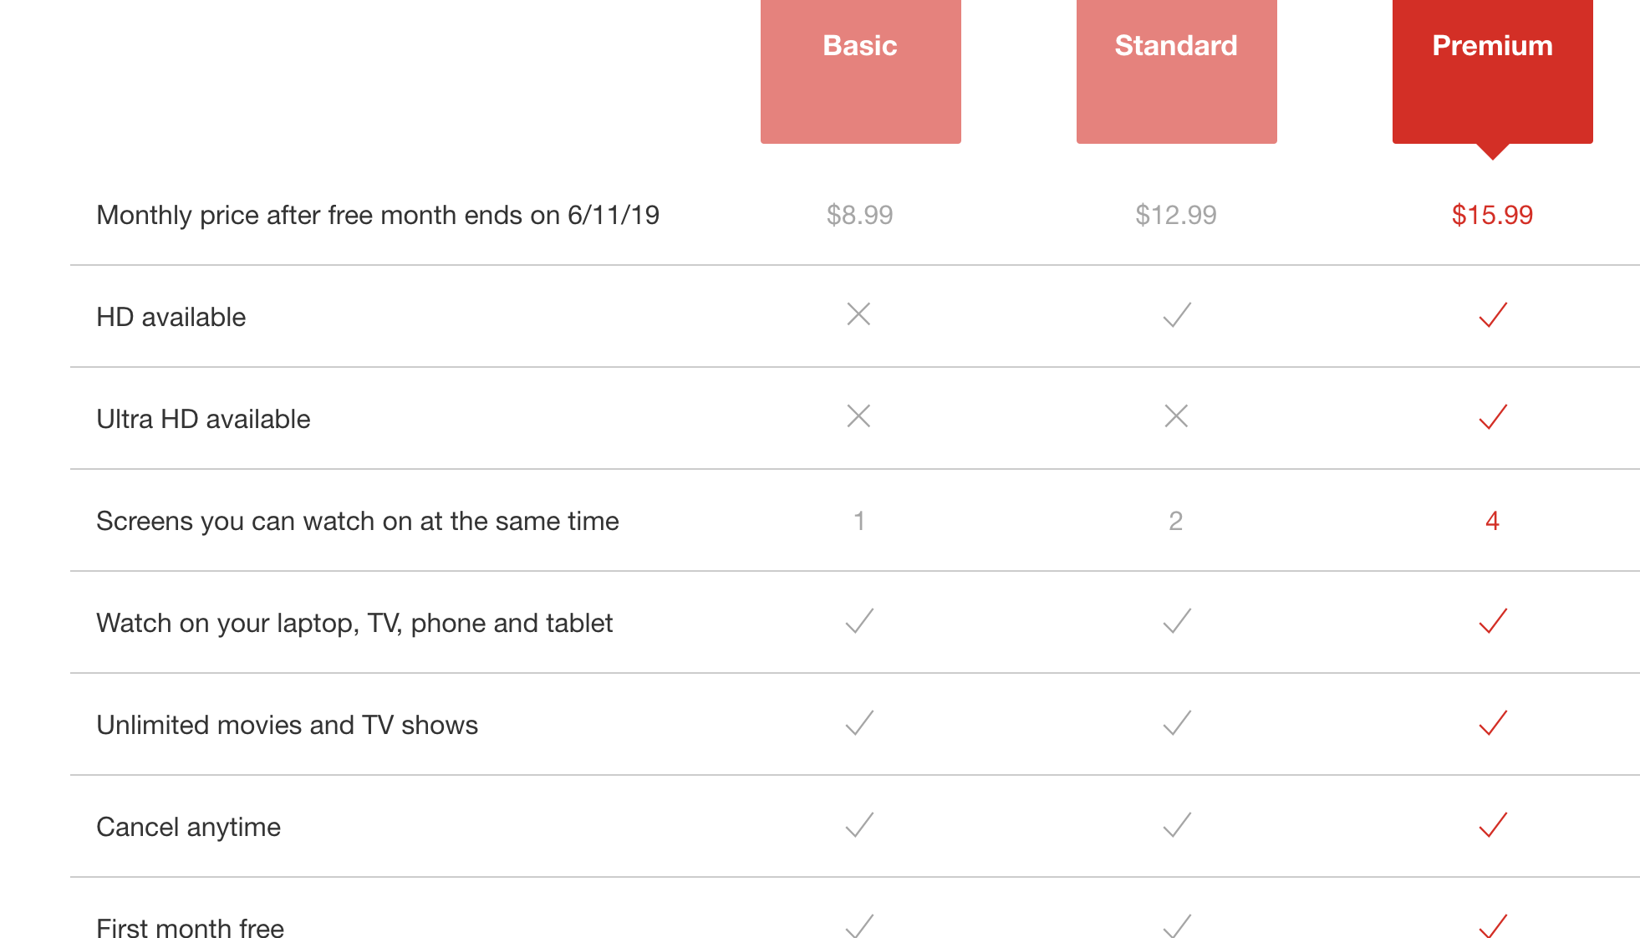

(Netflix, 2019)

**Exhibit B:**

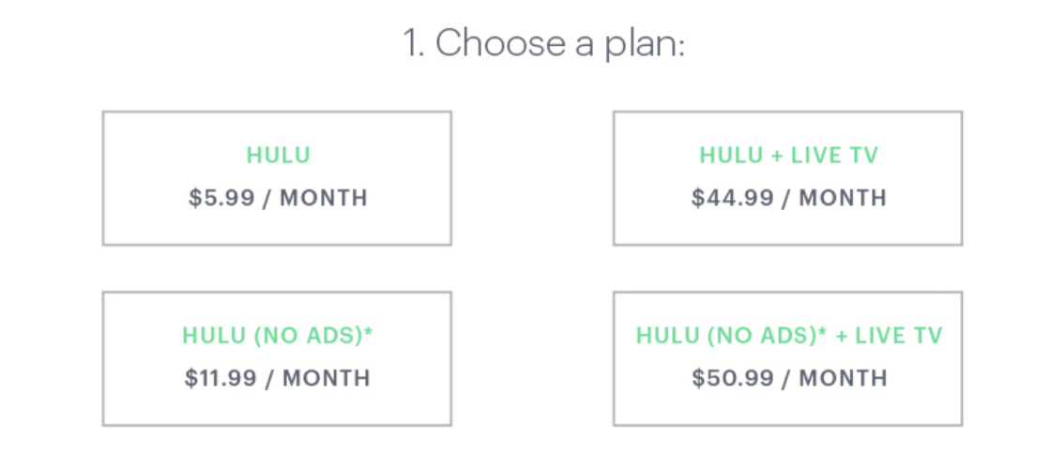

(Hulu, 2019)

**Appendix B:**

Netflix Original Content Ratio

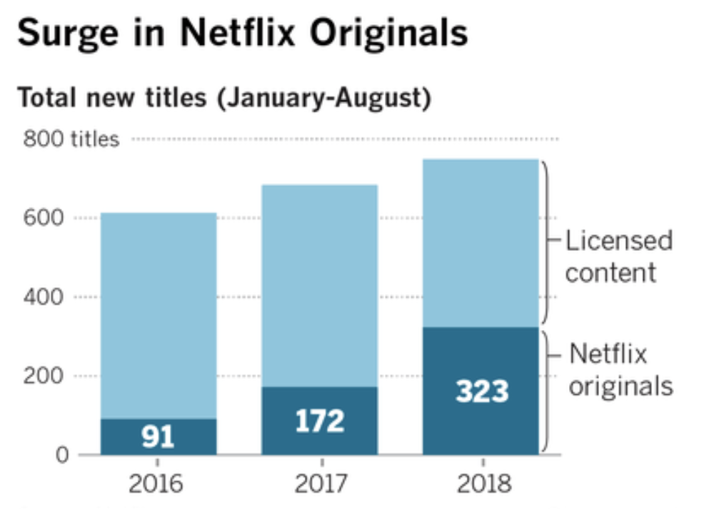

(David, 2018)

**Bibliography:**

Binder, Matt. “Disney Unveils the Name of Its Netflix Competitor, plus New Marvel and Star

Wars Shows.” *Mashable*, Mashable, 9 Nov. 2018,

mashable.com/article/disney-plus-streaming-service/

Bort, Julie. “Netflix Employees Are Happier With Their Job Than Facebook or Google

Employees.” *Inc.com*, Inc., 31 Oct. 2017,

www.inc.com/business-insider/tech-employees-anonymously-rate-companies-work-faceb

Even on Slow Internet.” *Quartz*, Quartz, 28 Feb. 2017,

Ook-gogle-netflix-twitter.html

qz.com/920857/netflix-nflx-uses-ai-in-its-new-codec-to-compress-video-scene-by-scene/

Griffith, Eric, et al. “Netflix vs. Hulu: Streaming Service Showdown.” *PCMAG*, 23 Jan. 2019,

www.pcmag.com/article/348989/netflix-vs-hulu-streaming-service-showdown

Hulu. “How Much Does Cost?” *Hulu.* 2019.

https://help.hulu.com/s/article/how-much-does-hulu-cost?language=en_US

Investopedia. “Netflix: Porter’s Five Forces Analysis.” *Investopedia*. 2019.

https://www.investopedia.com/university/netflix-porters-5-forces-analysis/

Molla, Rani. “Netflix Now Has Nearly 118 Million Streaming Subscribers Globally.” *Vox*, Vox,

22 Jan. 2018.

www.vox.com/2018/1/22/16920150/netflix-q4-2017-earnings-subscribers

Netflix. “Choose a Plan That’s Right for You.” *Netflix*. 2019

https://www.netflix.com/signup/planform

Ng, David. “As Netflix Surges, Original Content Is the New Black. But Licensed Shows Still

Take the Crown.” *Los Angeles Times*, Los Angeles Times, 12 Aug. 2018,

www.latimes.com/business/hollywood/la-fi-ct-netflix-programming-surge-20180812-sto

y.html

“Strengths | Weaknesses | Opportunities | Threat | Analysis-NFLX.” *Google Sites*,

sites.google.com/a/email.vccs.edu/netflix/home/website-builder

Wong, Joon Ian. “Netflix's New AI Tweaks Each Scene Individually to Make Video Look Good